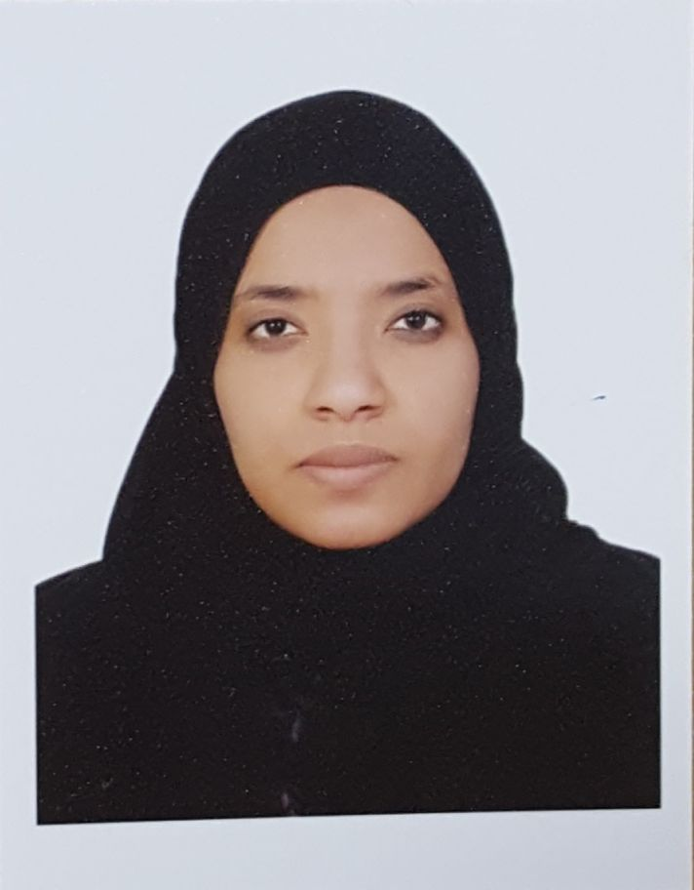
CURRICULUM VITAE
Dr. Sozan Mohamed Fadl
MBBS, MD Clinical Microbiology

Name: Sozan Mohamed Abdelkhalig Mohamed Fadl.
Sex: female.
Nationality: Sudanese.
D.O.B: 17/07/1977
Residence: Khartoum \Sudan.
Marital Status: Married.
Languages: Arabic - English (fluent speaker & writer)
Telephone: 00966532187811
Email: dr.sozan77@gmail.com dr.sus@live.com
Residence Permit (Iqama) No.: 2354460517

CURRENT JOB:
Assistant Professor- Almaarefa Colleges, Direyah, Riyadh, KSA (since August, 2014)

PREVIOUS JOBS:
- Head Virology Department - National Public Health Laboratory, Khartoum, Sudan (2012-2014).
- International Health Regulations focal person in laboratory core capacity, Khartoum, Sudan (2012-2014).
- Assistant professor - Omdurman Islamic University (2012-2013).
- Assistant Professor - Al Razi Medical & Technology College (2013-2014).
General practitioner - Virology department - National Public Health Laboratory (June 2006 - May 2008)
General practitioner - Military Hospital (April 2005 -April 2006).

EDUCATIONAL PROCESS:
- Medical doctorate (MD) - Clinical Microbiology from Sudan Medical Specializations Board. Specialist in Clinical Microbiology - July\2012
- MBBS - medicine and surgery from Omdurman Islamic University, Faculty of Medicine .November 2002.
- Excellent degrees in Pathology and Microbiology.
- Houseman ship - 4 major branches (Obstetrics and Gynecology, Medicine, Surgery and Pediatrics medicine) and 2 minors (Orthopedics) from April 2003 to September 2004.
- Selected for MD pathology at University of Khartoum and trained there for one and half years (February 2005 - September 2006)
- First part MD Clinical Microbiology and Infectious Diseases in January 2007.
- First part MD Clinical Immunology in January 2007.
- Had IELTS certificate with overall score of 7 in April 2010.

RESEARCHES & PUBLICATIONS:

- Viral and Bacterial Pneumonia in Children Attending Khartoum Emergency Pediatrics Hospital. Published on September 2015.
http://www.academicjournals.org/journal/JPHE/article-abstract/EF2CCE354915
- Concomitant Outbreaks of Yellow Fever and Hepatitis E Virus in Darfur States, Sudan 2012. Published on January 2016.
http://www.jidc.org/index.php/journal/article/view/26829534/1436
- Risk Assessment of Yellow Fever Infection in Sudan -December 2012- June 2013 (under publishing).
- Evidence of active Zika virus circulation in Sudan, a cross-sectional community-based study conducted in 2012(under publishing).

TRAINING COURSES:
- Research Methodology - 2011 (Sudan Medical Specialization Board)
- Laboratory Based Influenza Virus Surveillance. June 2012 (World Health Organization & Naval American Medical Research Unit 3)
- Laboratory Management and Leadership workshop. (World Health Organization and Royal Tropical Institute in Netherlands). March\2013
- Detection and Genotyping of Rota virus. November 2014 (World Health Organization & Naval American Medical Research Unit 3).
- Using SPSS for Data Analysis (8-12 April 2016, Al-Faisal University, Riyadh).
- Leadership, Power and Influence (November 2016, Al-Maarefa Colleges).

CONFERENCES AND WORKSHOPS:
- Mycetoma Conference 2009 (Soba University Hospital).
- Mycetoma Conference 2011 (Soba University Hospital).
- 10th annual inter country meeting on integrated surveillance and response to Meningitis, Yellow Fever, Measles and Cholera epidemics in Africa, Lomé, Togo, 24 - 26 September 2012.
- Implementation of International Health regulations In Sudan. February 2013 (World Health Organization/ Sudan).
- Saudi International Medical Education Conference- SIMEC 2016/ American College of Physicians Saudi Chapter Meeting. (Riyadh, Al-Faisal University, April 2016).
- 3rd Annual Microbiology & Infectious Diseases Asia Congress (Singapore, October 2016).
- 2nd Conference of Saudi for Health administration, Health Services Transformation Management 2030 (Riyadh, November 2016).
- 2nd Gulf Congress of Clinical Microbiology and Infectious Diseases, (Manama, Bahrain 1st - 4th November 2017).
- ExamSoft for online assessment workshop (Al-Faisal University, 9 November 2017).

TRAINING:
- Medical Parasitology department - National Health Laboratory - five months.
- Immunology department - National Health Laboratory - three months.
- Medical Mycology department - Faculty of Medicine, Khartoum University - seven months.
Reference Laboratory of Tuberculosis - National Health Laboratory - six months.
- Food and Water Bacteriology - three months.
- Virology Department - National Public Health Laboratory - 5 months
- Bacteriology laboratory - Khartoum Teaching Hospital - seven months
- Molecular analysis laboratory - National Public Health Laboratory - 2 months

REFERNCES:
Professor Abdalmageed kambal
King Saaud University head department microbiology
Email: kambalamg6@gmail.com
Mobile: 00966556026262 00966503202291
Prof. Elsheikh Mahgoub, MD, PHD, FRCPath, Dept. of Microbiology &Parasitology Faculty of Medicine, University of Khartoum.
Tel: 00249912385088 00249912323936
Email: mahgoubsh@gmail.com
Dr Najeeb Saeed. MD, MRCPath. Head Department of Microbiology &Parasitology Faculty of Medicine, University of Khartoum.
Tel: 00249912390379 00249123393392
Email: nagebsaeed@yahoo.com nagebsaeed@gmail.com

